**Shri Govindram Seksaria Institute of Technology and Science (SGSITS)**

Name: Manshi Pal

Email Id: [manshipal27@gmail.com](mailto:manshipal27@gmail.com)

Hotel Booking cancellation

When running a successful and demanding hospitality business, most hotel owners like a hotel that is running at full capacity and bringing in sizeable revenue. Most of the time hotel booking cancellations can be hurtful to business owners; although sometimes there are genuine reasons for guests to do so. These last-minute cancellations can result in lost revenue unless some measures are undertaken to mitigate the loss. The purpose of this project is to analyze Hotel Bookings data, investigate cancellations, and their underlying patterns; and suggest measures that can be implemented to reduce cancellations and secure revenue.



Assumption

1. No unusual occurrences between 2015 and 2017 will have a substantial impact on the data used.
2. The information is still current and can be used to analyze a hotel’s possible plans in an efficient manner.
3. There are no unanticipated negatives to the hotel employing any advised technique.
4. The hotel are not currently using any of the suggested solutions.
5. The biggest factor affecting the effectiveness of earning income is booking cancellation.
6. Cancellation results in vacant room for the booked length of time.
7. Clients make hotel reservation the same year they make cancellations.

Hypothesis

1. More cancellations occur when prices are higher.
2. When there is a longer waiting list, customers tend to cancel more frequently.
3. The majority of clients are coming from offline travel agents to make their reservations.

Analysis and Findings

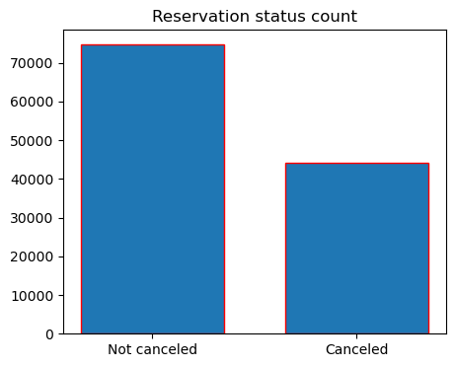

The accompanying bar graph shows the percentage of reservations that are cancelled and those that are not. It's obvious that there are still a significant number of reservations that have not been cancelled. There are still 37% of clients who cancelled their reservation which has a significant impact on the hotel's earning.

**Reservation Status in different hotels.**

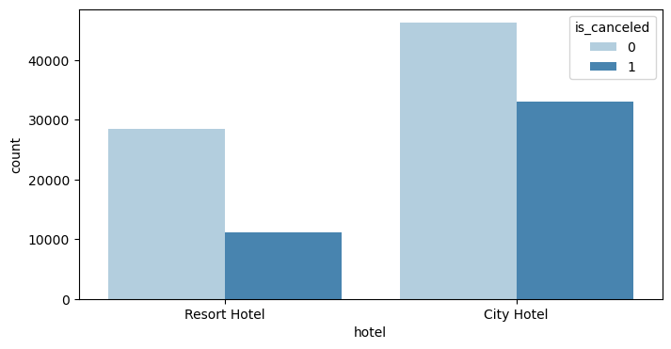

In comparsion to resort hotels, city hotels have more bookings. It's possible that resort hotels are more expensive than those in cities.

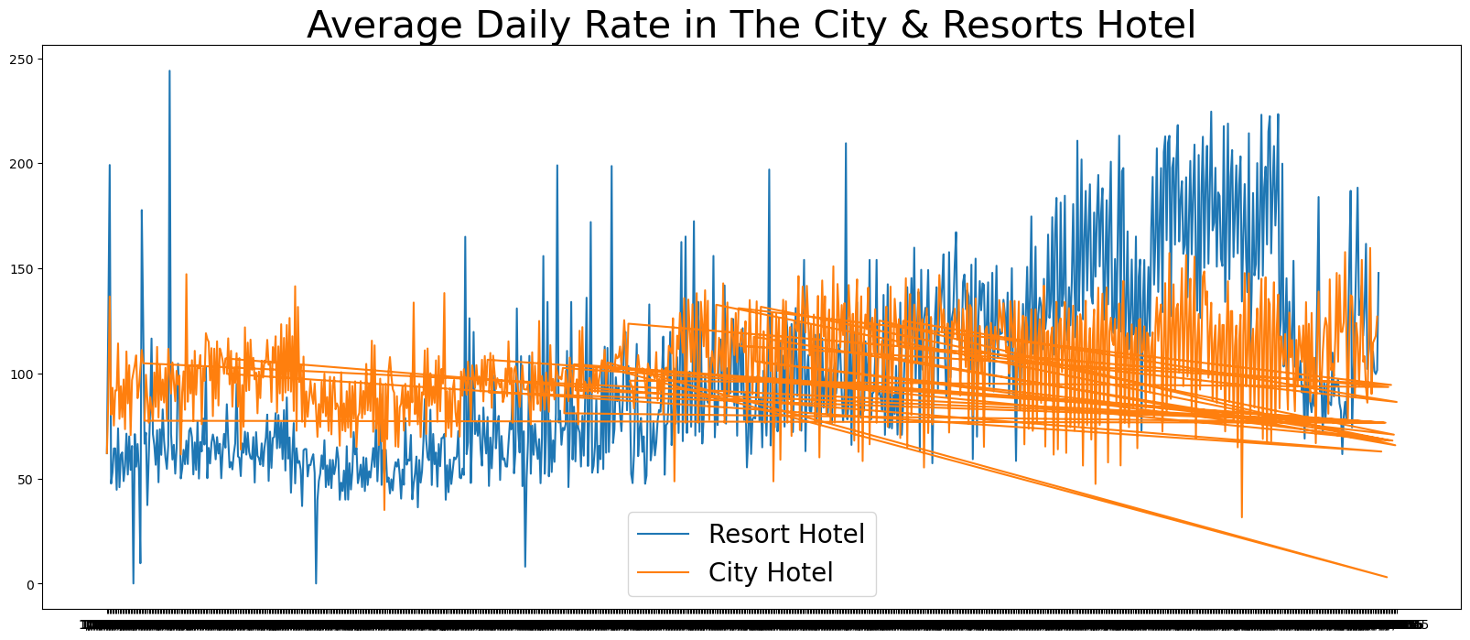

The line graph above shows that on certain days, the average daily rate for a city hotel is less than that of a resort hotel, and on other days it is even less. Weekends and holidays may see a rise in resort hotel rates.

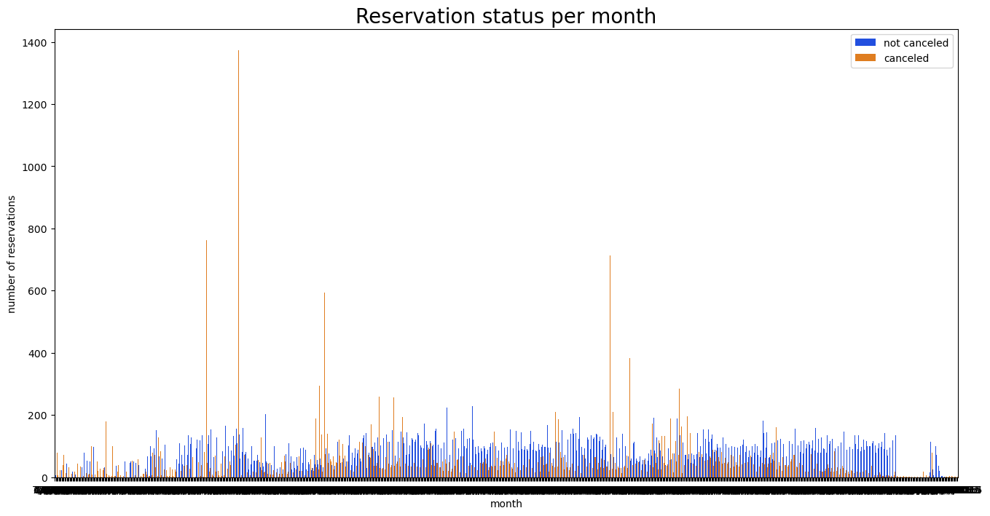

We have developed the grouped bar graph to analyze the months with the highest and lowest reservation levels according to reservations and the number of cancelled reservations are largest in the month of august. Where as January is the month with the most cancelled reservations.

Now, let's see which country has the highest elevation cancelled. The top country is Portugal with the highest number of cancellactions

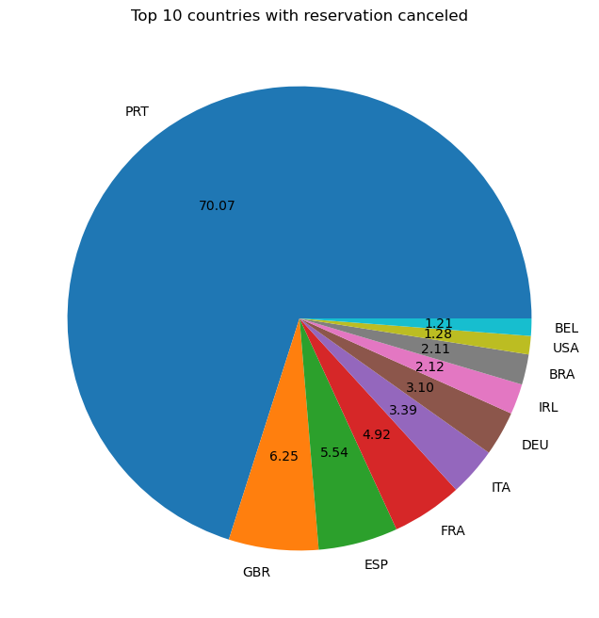

Around 46% of the clients come from online travel agencies, whereas 27% come from groups. Only 4% of clients book hotels directly by visiting them and making reservations.

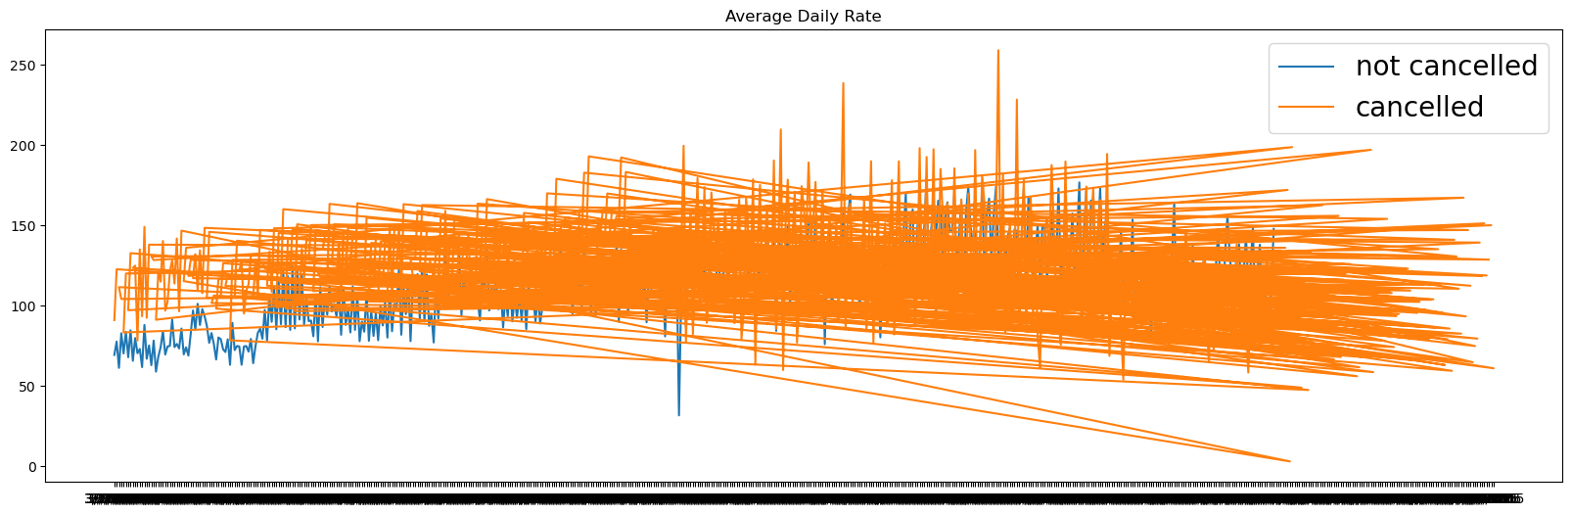

As seen in the graph, reservations are canceled when the average daily rate is higher than when it's not cancelled. It proves all the above analysis, that the higher price leads to higher cancellations.

Suggestions

1. Cancellation rates rise as the price does to prevent cancellations of reservations hotels could work on their pricing strategies and try to lower the rates for specific hotels based on location. They can also provide some discounts to the consumers
2. As the ratio of the cancellation and not cancellation of the resort hotel higher in the city hotels. So the hotels should provide a reasonable discount on the room prices on weekends or holidays.
3. They can also increase the quality of the hotels and the services mainly in Portugal to reduce the cancellation rate.